Name: _______________________________________ Period: ____
Writing Tabloid Fiction

Sure, they’ll never win a Pulitzer Prize, but tabloids have their uses. They teach us to believe (Elvis Lives!), to better ourselves (The Amazing Ice Diet!), and to have compassion (Bat Baby Needs Your Help!). They can also teach us to be better writers. This writing task uses tabloids to explore what makes good writing good and bad writing bad, and why the latter can often be a lot of fun to write.

The Specifics of the Writing Task:
Choose 1 of 6 provided prompts and use that stimulus to write a 1-page piece of tabloid fiction.
You are expected to include at least two of the following tabloid risks*:
- Clichés
- Hyperbole
- Alliteration
- Element of the Supernatural
- Absurd or Improbable Events
- Shocking, Tell-All Confessional
*Use the resources in this packet to guide you!

Furthermore, as with traditional or real news stories, you’re going to want to:
- quote sources (of course, these can be fake) for dramatic effect
- answer the basic questions of journalism: who, what where, when, and why?
- construct the final single-page product in an interesting and appealing manner

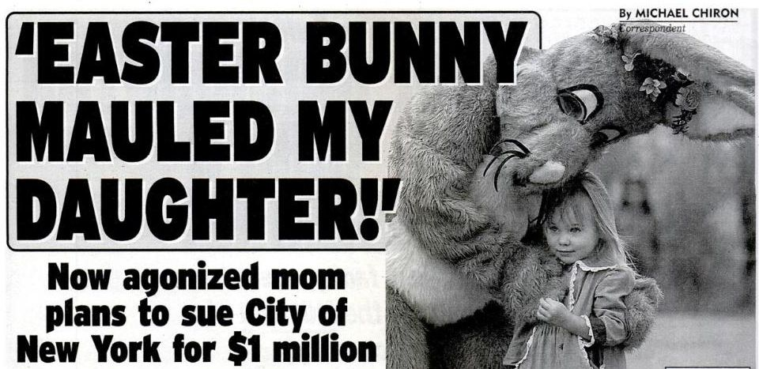
Tabloid fiction is meant to be fun for the reader; thus, you should have fun writing it!

