Writing Tabloid Fiction
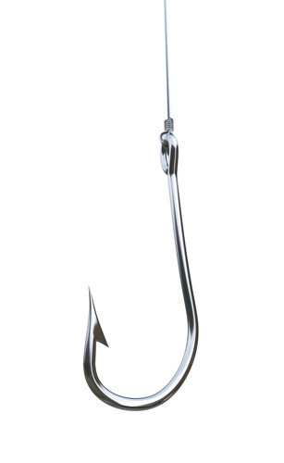
Get Hooked!

Effective and engaging leads from some of this week’s tabloid articles:

- Jim Smith, Bigfoot expert and noted wilderness guide, estimated that there may be as many as 500 of the unclassified creatures living in the forests of Oregon.

- At Jewelry stores in Manhattan, trust between merchants has been violated.

- Coca-Cola and PepsiCo said Monday they’re working to remove a controversial ingredient from all their drinks, including Mountain Dew, Fanta and Powerade.

- An overenthusiastic boy-band fan who attempted to assassinate former U.S. President Ronald Reagan in 1981 has been given conditional release from a mental institution.

- Ben Affleck’s blackjack days are over—at least at the Hard Rock in Vegas—because he was just banned for life from playing the game at the casino after security says they caught him counting cards.

- Authorities are advising you to stay indoors this Friday, as an asteroid is predicted to ricochet off of the North Pole at 8:46pm.

- Taco Bell has revealed the “special” secret ingredients that go into its famous mystery beef.

